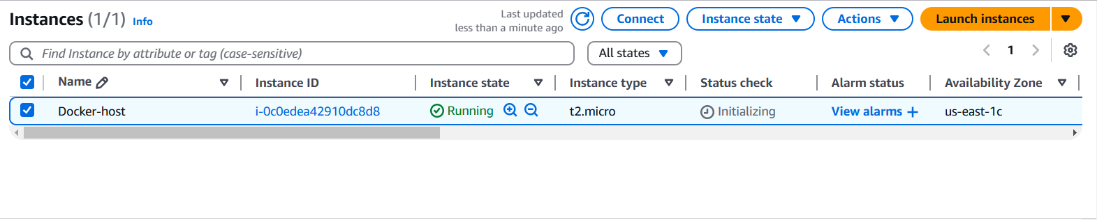

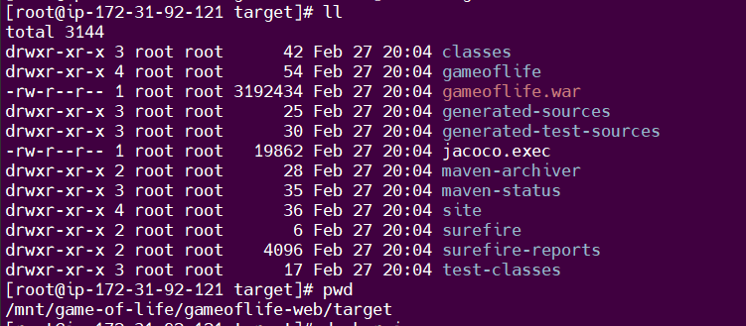

create Dockerfile –

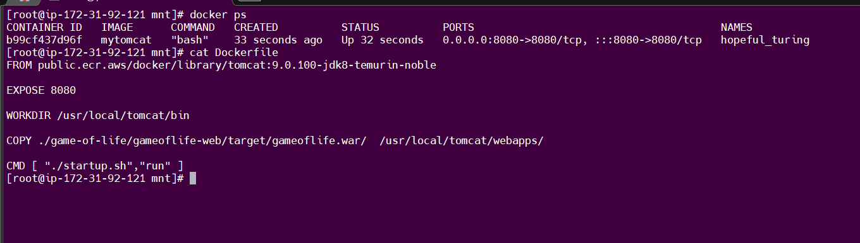

FROM public.ecr.aws/docker/library/tomcat:9.0.100-jdk8-temurin-noble

EXPOSE 8080

WORKDIR /usr/local/tomcat/bin

COPY ./game-of-life/gameoflife-web/target/gameoflife.war/ /usr/local/tomcat/webapps/

CMD [ "./startup.sh","run" ]

Output –

